BIG I ALABAMA
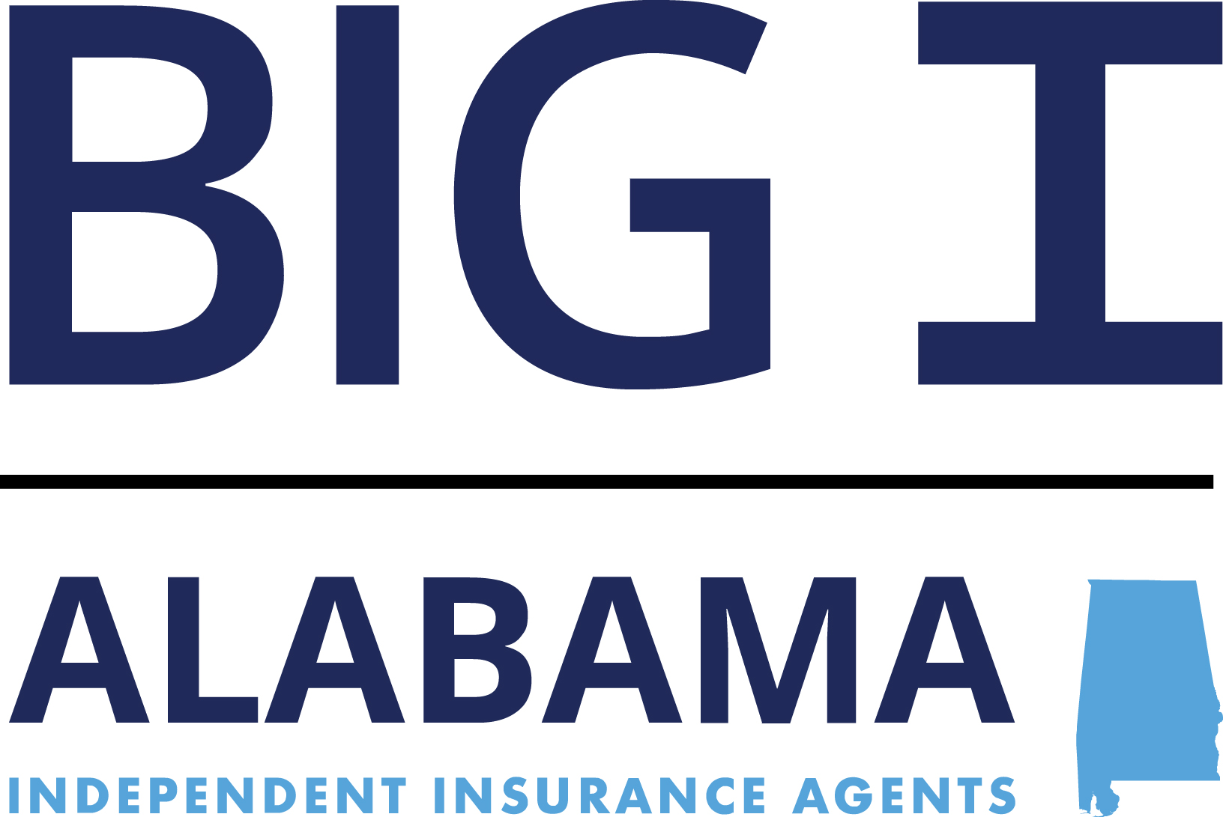

141 LONDON PARKWAY

BIRMINGHAM, AL 35211
PHONE 205-326-4129
www.aiia.org

2026 “INSUROR OF THE YEAR”
AWARD

NOMINATION FORM

- NOMINATING PARTY
This nomination is being submitted by:

NAME_________________________________________________________________

AGENCY______________________________________________________________

PHONE_________________ FAX_________________ EMAIL_________________

- NOMINEE

NAME OF NOMINEE___________________________________________________

AGENCY_____________________________________________________________

PHONE______________________ FAX_______________________

- QUALIFICATIONS

In the space provided, describe the nominee’s contribution to the Independent Agency business and/or to the national, state or local community that, in your opinion, qualifies the nominee for the “INSUROR OF THE YEAR” award.

_____________________________________________________________________________________

_____________________________________________________________________________________

_____________________________________________________________________________________

_____________________________________________________________________________________

Page 2

_____________________________________________________________________________________

_____________________________________________________________________________________

_____________________________________________________________________________________

_____________________________________________________________________________________

_____________________________________________________________________________________

_____________________________________________________________________________________

_____________________________________________________________________________________

_____________________________________________________________________________________

_____________________________________________________________________________________

_____________________________________________________________________________________

_______________________________________________
Signature – Nominating Party

Big I Alabama

Please return nomination for “INSUROR OF THE YEAR” to:

Attn.: Michelle McKee
141 London Parkway
Birmingham, AL 35211
Email: mmckee@aiia.org

Nominations need to be returned no later than Friday, May 15th, 2026.
to have awards made prior to the Convention.

